Created user name in git and added

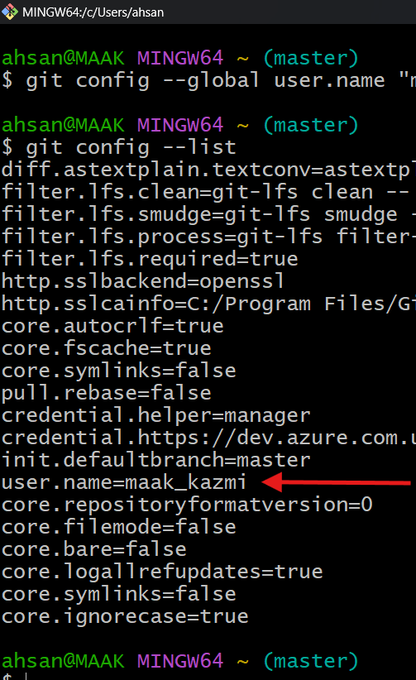

Added to repository track , $git log
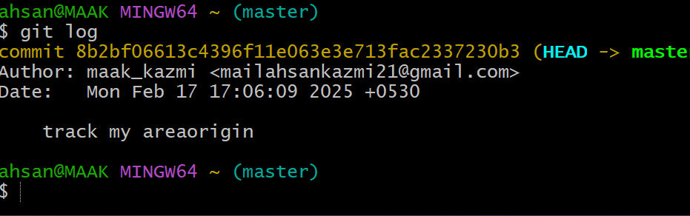

Using command
Git remote –v
Git push –v originmaster
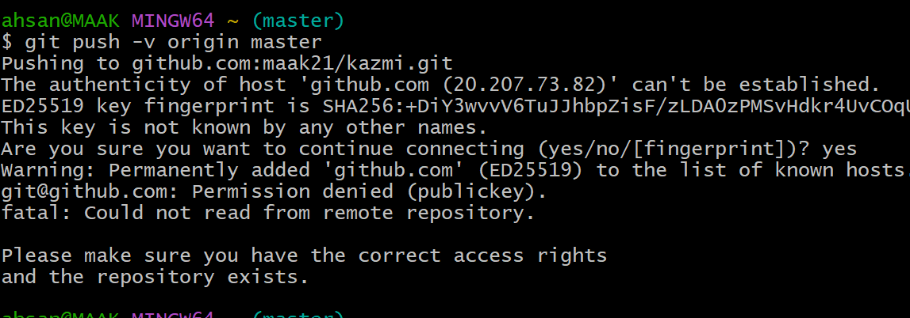

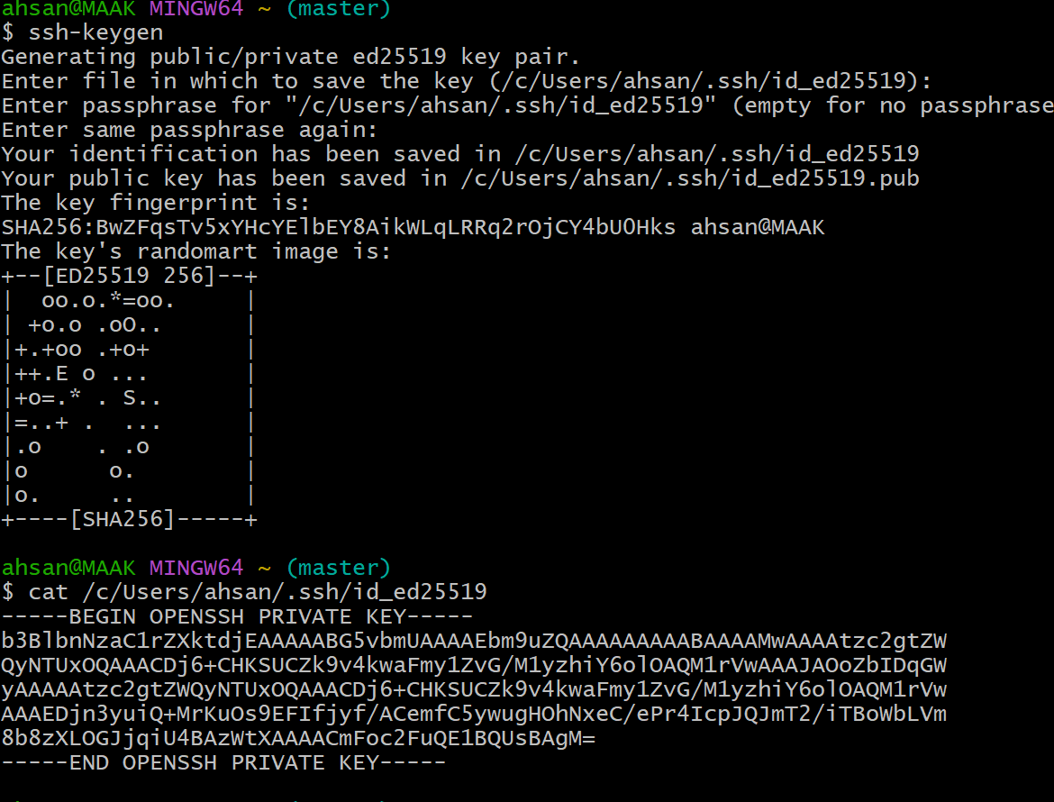

Another option if ssh key not correct generate
$cd ~/.ssh
$ll
File name id-ed25519.pub
Cat filename
You will get key
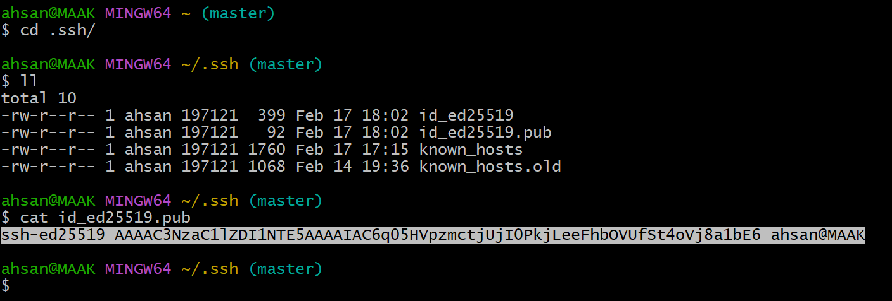
After $get push –u origin master
This page will occer

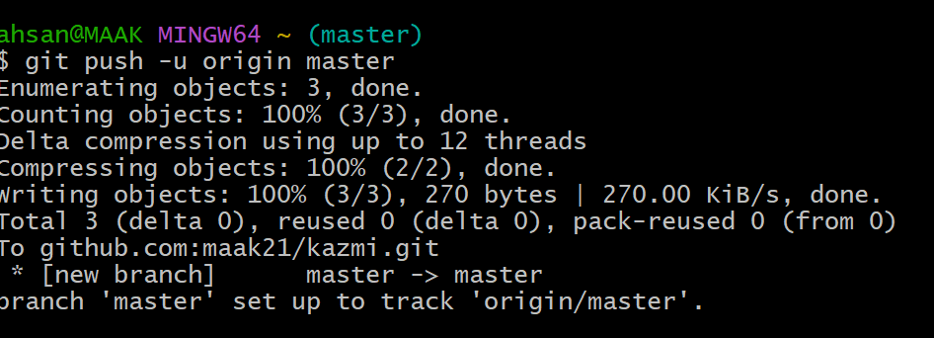

Now data got transferred centeral repository
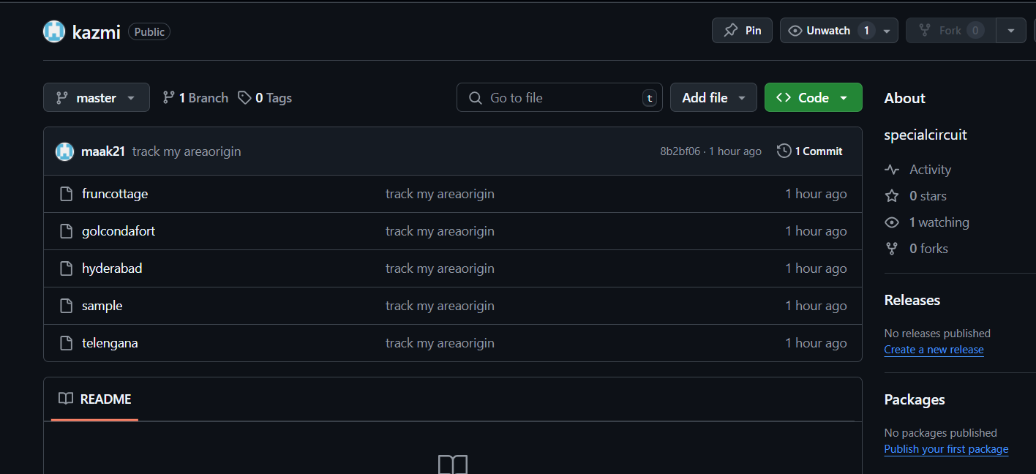

I HAVE MOVE THE REPOSITORY FROM ONE REPOSITORY TO ANOTHER REPOSITROY USING COMMED CHEERY PIC
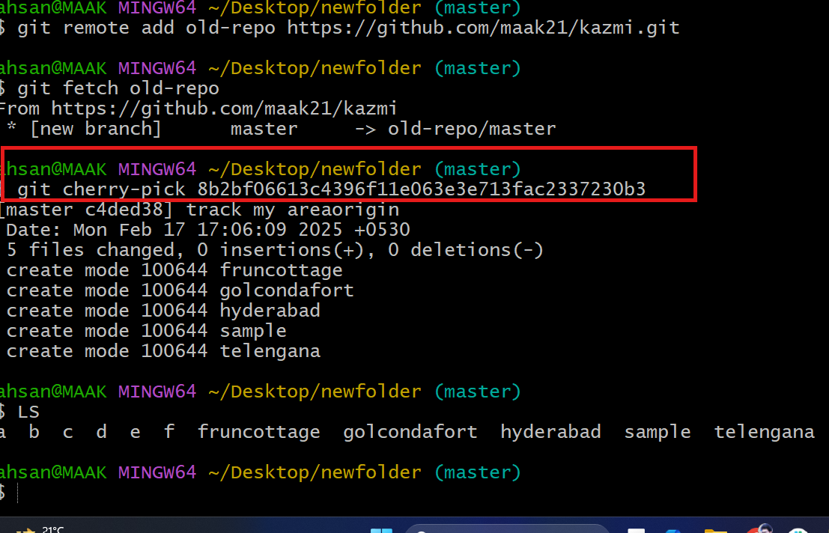

your local branch and the remote origin/master branch have diverged, which means there are different commits on each branch. Here’s how you can synchronize them:
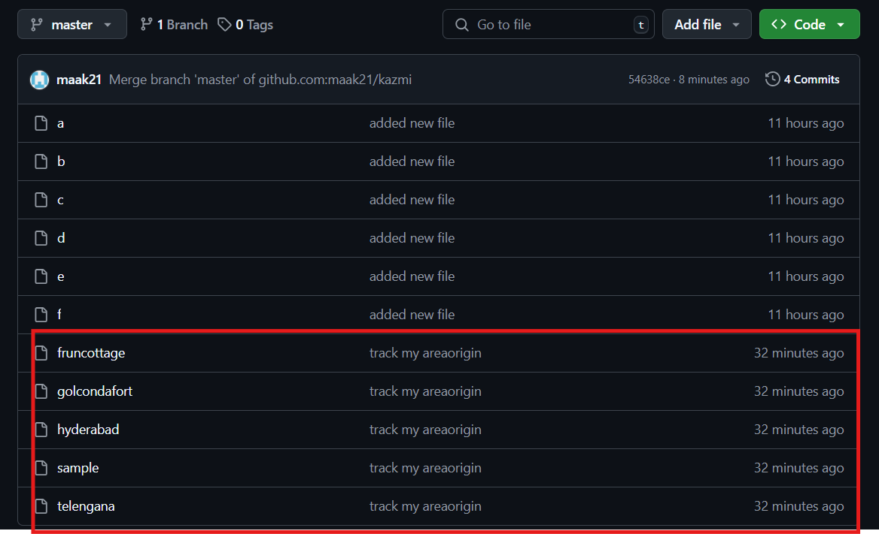

Done with the cloning command
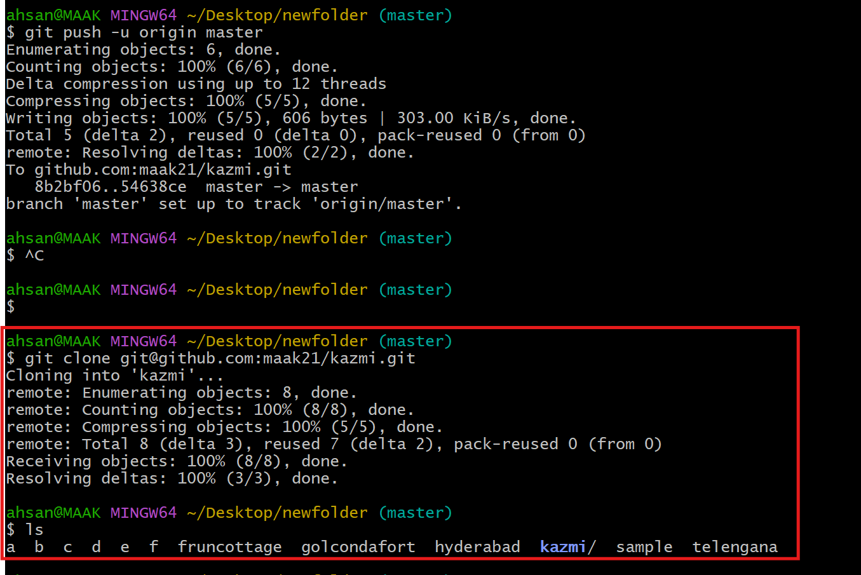

Using pull command to get sychrojm from centeral repository to local machine
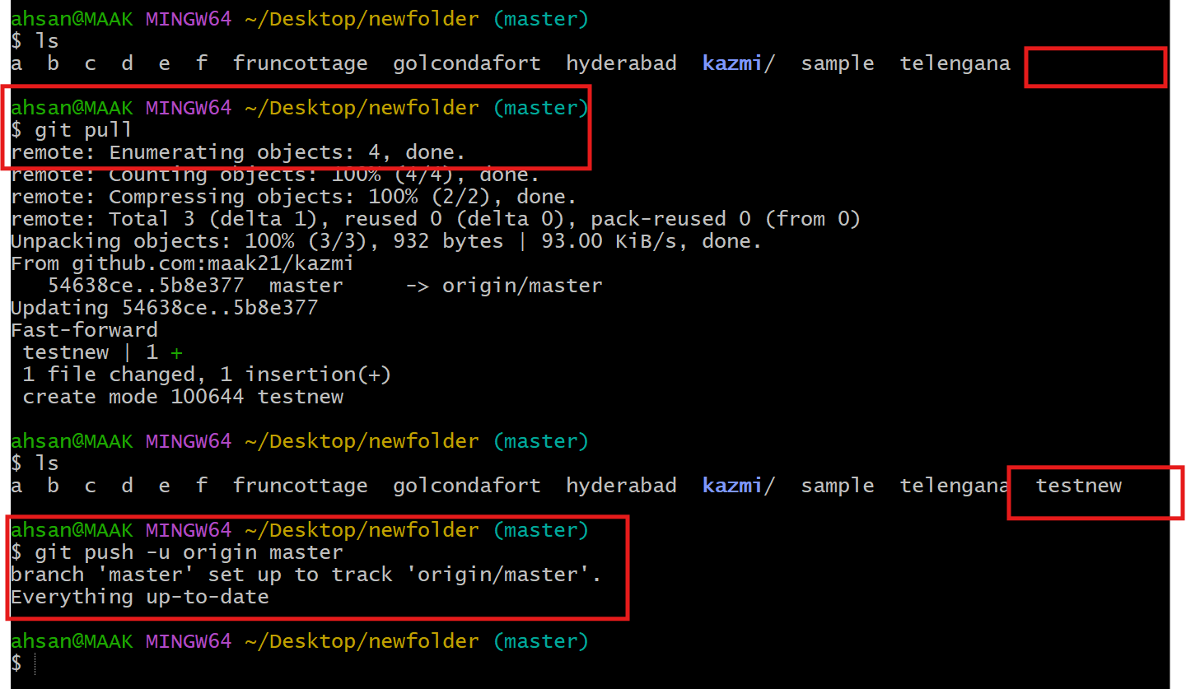

Git log it shows merge the master 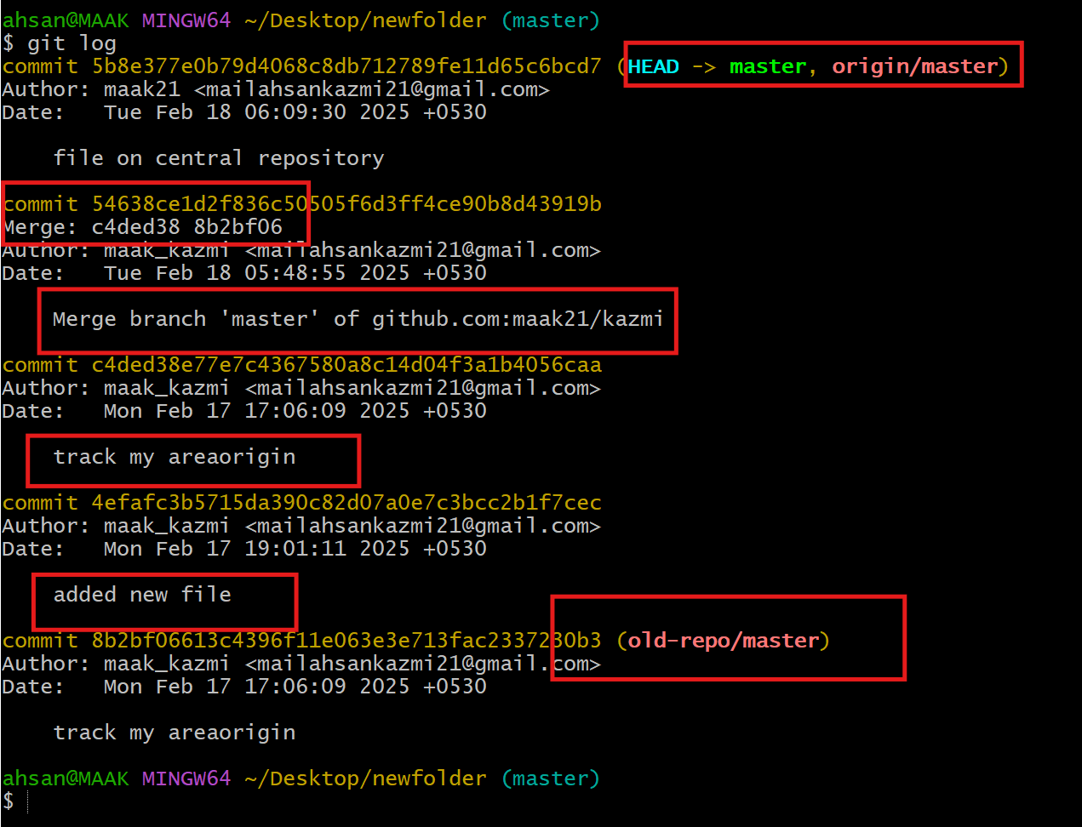
Git remote –v
It shows the all removte repository including old repo including fetch
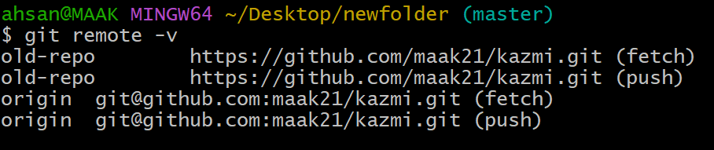

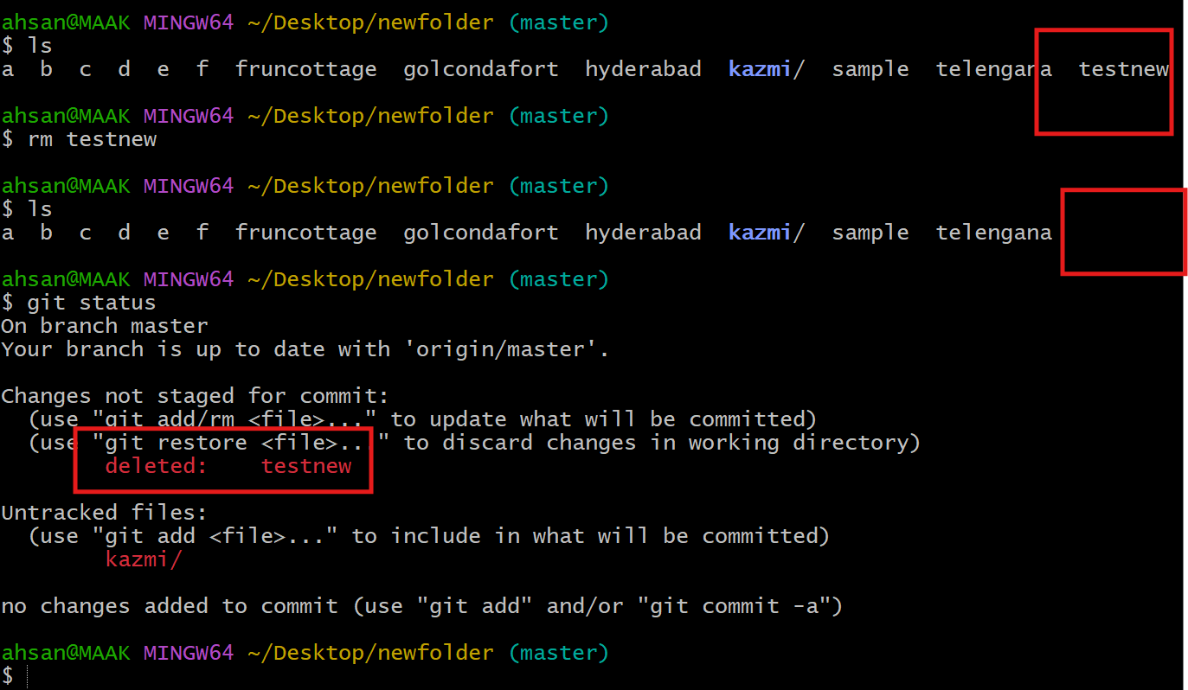

Delted file testnew by using comments
rm testnew
git add .

git commit -m "deleted testnew"

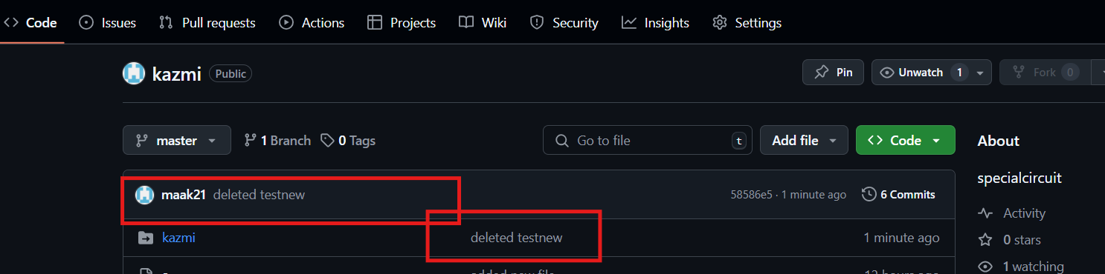

To get back deleted file
Go to
Git log ( it shows all the log files)
Git log -4 (it shows all 4 lines of log
git revert 58586e

